
Name: ________________________________________ Class: ______Date: ________________

ENVIRONMENTAL SCIENCE TEST 1 REVISION GUIDE
The test will cover Environmental Science Book pages 2-6.

1 List the seven characteristics of living things:
_____________________________________________________________________________________________
_____________________________________________________________________________________________
2 Circle the non-living organisms in the picture below:
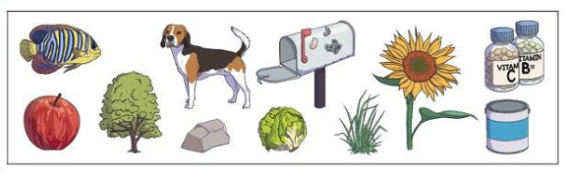
3 Match the definition to the word by writing the correct letter on the line.
_____ Ecosystem A) All the different species that live together in an area.
_____ Population B) One type of living thing living in an area.
_____ Community C) Living things interacting with each other and their environment.
_____Biotic D) Living things.
_____Abiotic E) Non-living things.

4 Label the pictures below with one of the words below.
Ecosystem Population Community

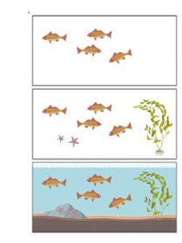
a) ___________________________________ c) _____________________________________
b) ___________________________________
5 Identify three (3) Biotic factors and three (3) Abiotic factors in the pond ecosystem below
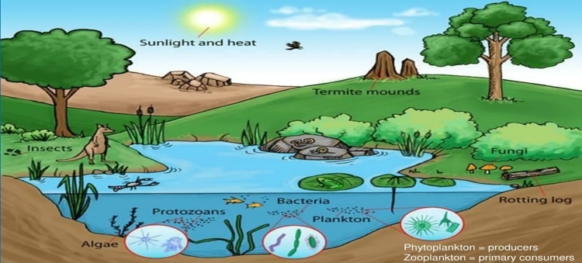
3 Biotic factors: 3 Abiotic factors:
_1__________________________________ __1_______________________________
_2_________________________________ __2_______________________________
_3__________________________________ __3_______________________________
6 What materials would you need to build a mini ecosystem in plastic bottle?
___________________________________________________________________________________________

